**ASSOCIATION BETWEEN ECONOMIC GROWTH AND GOVERNMENT EXPENDITURE ON DIFFERENT DEPARTMENTS IN THE UK**

Group Members:

Hasan Abbas

Pratik Chhetri

Ethan Fernandes

Prashil Mehta

Module: Economic Data Analysis (ECO1017)

University of Surrey

2022

Word Count = 2928 (Excluding Table of Contents and References)

Table of Contents

1 Introduction 2

1.1 Motivation 2

1.2 Objective 2

1.3 Key Findings 2

2 Data Description 3

2.1 Data Sources 3

2.2 Variable: GDP per Capita in GBP (£) 3

2.3 Variable: Government Expenditure on Education per capita 4

2.4 Variable: Government Expenditure on Social Protection per capita 5

2.5 Variable: Government Expenditure on Healthcare per capita 6

3 Analysis 7

3.1 Analysing the relationship between GDP per capita and Government expenditure on Education per capita 7

3.2 Analysing the relationship between GDP per capita and Government expenditure on Social Protection per capita 8

3.3 Analysing the relationship between GDP per capita and Health expenditure per capita 9

4 Discussion 10

4.1 Government expenditure on Education per capita and GDP per capita 10

4.2 Government expenditure on Social Protection per capita and GDP per capita 10

4.3 Government expenditure on Healthcare per capita and GDP per capita. 10

5 Conclusion 11

6 References 12

# 1 Introduction

## 1.1 Motivation

As a society experiences economic development and growth, their quality of life will increase, therefore meaning that as the country gets richer and so the people’s income rises, their subjective well-being will increase. This is the premise of the Easterlin paradox put forward by Professor Richard Easterlin where he conducted surveys and data from 19 different countries. Now that we have depicted why economic development should be desired in all economies, we must ask the question how does an economy achieve this and what role should the government play for us to achieve this?

In the UK, the OBR forecasts that the government will spend approximately £1.182 trillion in 2022-2023. This is equivalent to 47.3% of our national income and averages to around £42,000 per person (OBR). However, this expenditure comes at a cost: they need these funds from tax revenue, meaning the government needs to carefully identify how much money they’ll get from taxes and how much to distribute to which public sector. Government expenditure estimated to be over £1 trillion indicates how huge the public sector is in the UK and how we can achieve economic growth largely depends on this. This study will analyse where government funds are best utilized to achieve economic growth and development by identifying the relationship GDP per capita has with these different public services.

## 1.2 Objective

The objective of this research report is to investigate the effects of the different components of UK public sector spending and how they individually contribute to the growth of the UK economy. Government expenditure is an important driving force in increasing the economic strength of the UK economy, hence why examining how the UK government uses its finances and its result on economic development is paramount in identifying just how the government should distribute these funds for the economy to successfully grow. The focus of this report is evaluating the relationship between GDP per capita and the relevant components we are examining in this research, which include expenditure on education, healthcare and social protection per capita.

## 1.3 Key Findings

The OECD stated that the UK economy was the worst performer in the G20 summit in 2022 aside from Russia (Strauss 2022). The UK also was stated to have the worst economic forecast for 2023 in the G7 countries, with GDP expected to fall by 0.4% which is just behind Germany whose GDP is expected to fall by 0.3% (Harari 2022). As for government expenditure, the UK has consistently remained below major European economies such as France, Italy and Spain, but has never been that far behind, with the UK’s government expenditure being 52.5% of GDP in 2020 and Spain being only 0.1% higher. IN 2020, the UK also had 2.2% more government expenditure than Germany (OECD 2021).

# 2 Data Description

## 2.1 Data Sources

The main data sources used in this report are the World Bank, the Office for National Statistics (ONS), Our World in data, Statista, Office for Budget Responsibility (OBR) and the Organisation for Economic Co-operation and Development (OECD). The World Bank is an international development organisation that lends money to governments of countries with worse economies to help them. The ONS is the UK’s largest publisher of statistics relating to the UK’s economy. Both Our World in Data and Statista are data platforms that provide world statistics. The OBR provides economic forecasts on public finances and the OECD is an international organisation that strives to stimulate global economic progress.

## 2.2 Variable: GDP per Capita in GBP (£)

GDP per capita measures the economic output per person and does this by dividing GDP by the population of the country. It is commonly used to measure the economic outlook of a country, and so when accounting for inflation, it can accurately be used to measure how much growth an economy has experienced.

 The time series, with the data being recorded from Statista, shows GDP per capita that has been adjusted for inflation so we can accurately see how the economy of the UK has changed over time, where GDP per capita has increased from £25,955 in 1988 to £31,793 in 2021.

Also, using the box plot and the statistics shown in the table below, the median is slightly higher than the mean and there is a long lower tail, which graphically demonstrates a negatively skewed distribution. (Time series, statistics and box plot was calculated using data values from Statista 2022)

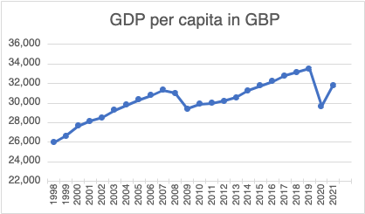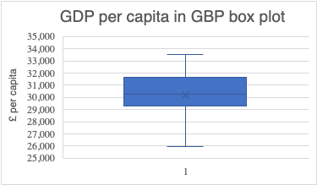

|  |  |
| --- | --- |
| Statistics | Values (in £) |
| Mean | 30,235 |
| Median | 30,272 |
| Q1 | 29377.25 |
| Q3 | 31442.5 |
| IQR | 2065.25 |
| Max | 33,510 |
| Min | 25,955 |
| Range | 7,555 |
| Standard Deviation | 1889.567054 |
| variance | 3570463.651 |
| Q3+1.5IQ | 34540.375 |
| Q1-1.5IQR | 26279.375 |

## 2.3 Variable: Government Expenditure on Education per capita

Government Expenditure on Education per capita is measured as the amount of public sector spending on education divided by the population. The graph shows data from 1998 to 2020.

The time series graph shows that there has been a positive increase over the years in government expenditure on education per capita where it has increased from roughly £1100 in 1998 to almost £1700 in 2020. Using the statistics shown in the box plot, no outliers are found meaning government expenditure on education per capita has been relatively consistent. However, the median is slightly higher than the mean, thus presenting a negatively skewed distribution. (Data from World Bank)

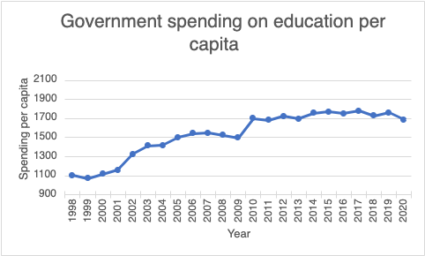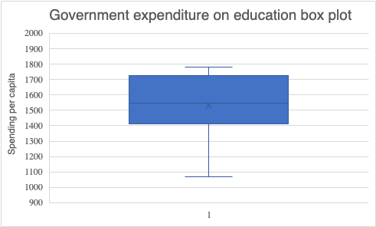

|  |  |
| --- | --- |
| Statistics | Values |
| Mean | 1531.998798 |
| Median | 1546.370644 |
| Q1 | 1414.363267 |
| Q3 | 1724.556016 |
| IQR | 310.1927489 |
| Max | 1779.365312 |
| Min | 1070.472091 |
| Range | 708.893221 |
| Standard Deviation | 230.8266695 |
| Variance | 54563.36872 |
| Q3+1.5*IQR | 2189.845139 |
| Q1-1.5*IQR | 949.0741436 |

## 2.4 Variable: Government Expenditure on Social Protection per capita

Government expenditure on Social Protection per capita is measured as the amount of public sector spending on social protection divided by the population. Social protection includes the benefits provided to households to help with their needs (usually those in poverty) such as unemployment benefits (ONS 2017) or even schemes like the furlough scheme during COVID.

The time series displays how spending on social protection has changed over the years from 1998-2021. From the graph, a positive increase can be seen where spending per capita has increased from 1998 where it was around £3200 to almost £4500 in 2021. However there does seem to be a leveling off from 2009 onwards.

Using the statistics, the median is higher than the mean and there is a long lower tail, which shows a negatively skewed box plot. However, there being no outliers shows how relatively consistent Social Protection spending has been.

|  |  |
| --- | --- |
| Statistics | Values |
| Mean | 4171.275304 |
| Median | 4402.4153 |
| Q1 | 3890.314025 |
| Q3 | 4520.568475 |
| IQR | 630.25445 |
| Max | 4734.3223 |
| Min | 3175.7215 |
| Range | 1558.6008 |
| Standard deviation | 459.2632654 |
| Variance | 210922.7469 |
| Q3+1.5*IQ | 5465.95015 |
| Q1-1.5*IQR | 2944.93235 |

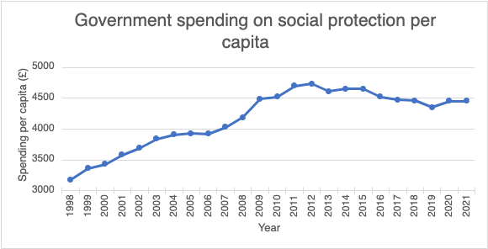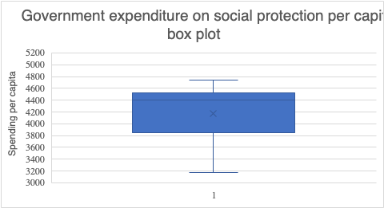

## 2.5 Variable: Government Expenditure on Healthcare per capita

Government Expenditure on Healthcare per capita is the amount the public sector spends on the NHS and hospital workers etc., divided by the population.

This time series illustrates data from 1998 to 2021 where there has been a positive increase in public sector spending on healthcare per capita, from around £1400 to roughly £3250. The box plot displays there being no outliers in spending on healthcare per capita but although the median is higher than the mean there is a long tail at the top of the box plot meaning it is not too negatively distributed. This is evidence of how the UK government made a huge jump in spending on healthcare during COVID, hence the long tail at the top of the box plot. (Data from Our world in data)

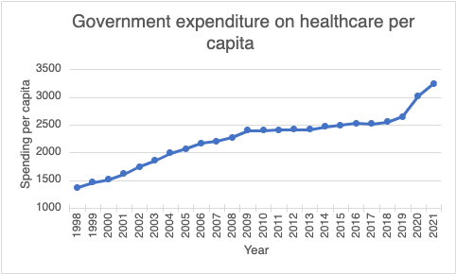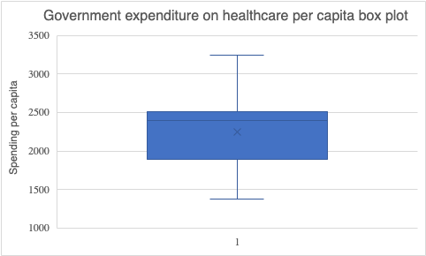

|  |  |
| --- | --- |
| Statistics | Values |
| Mean | 2243.99718 |
| Median | 2400.94980 |
| Q1 | 1960.44337 |
| Q3 | 2502.49661 |
| IQR | 542.053247 |
| Max | 3246.55929 |
| Min | 1376.20372 |
| Range | 1870.35557 |
| Standard deviation | 459.4023593 |
| Variance | 211050.527 |
| Q3+1.5*IQ | 3315.57648 |
| Q1-1.5*IQR | 1147.36349 |

# 3 Analysis

## 3.1 Analysing the relationship between GDP per capita and Government expenditure on Education per capita

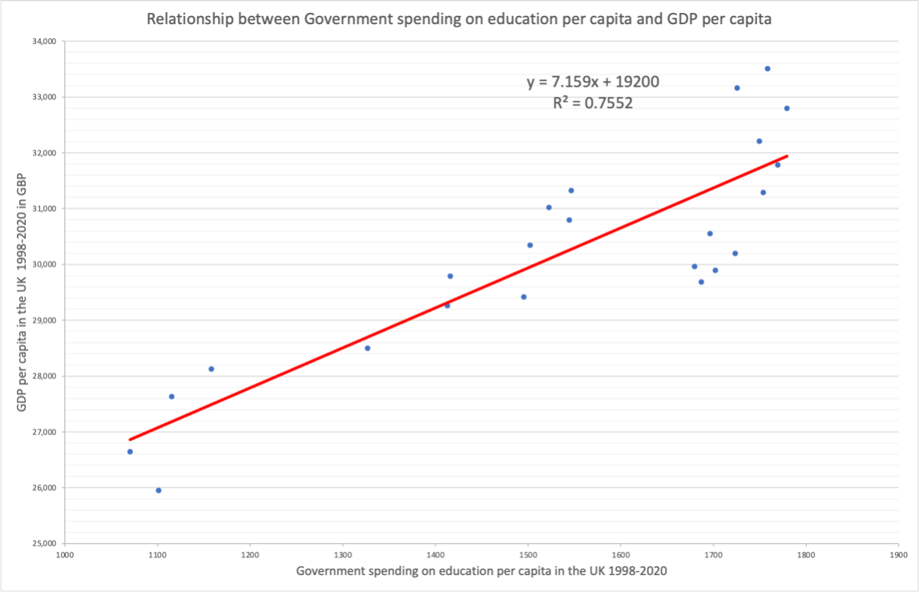

The scatter plot displays the relationship between public expenditure on education per capita and GDP per capita from 1998 to 2020, with education expenditure being the predictor variable and GDP per capita being the response variable. The correlation value (r value is found in our excel workbook) was calculated to be 0.869, which depicts a strong positive correlation between the two variables. This informs us that as government expenditure on education increases, GDP per capita also increases and there is economic growth. The gradient being equal to 7.159 means that for every unit increase in government expenditure on education per capita, GDP will roughly increase by 7.159.

## 3.2 Analysing the relationship between GDP per capita and Government expenditure on Social Protection per capita

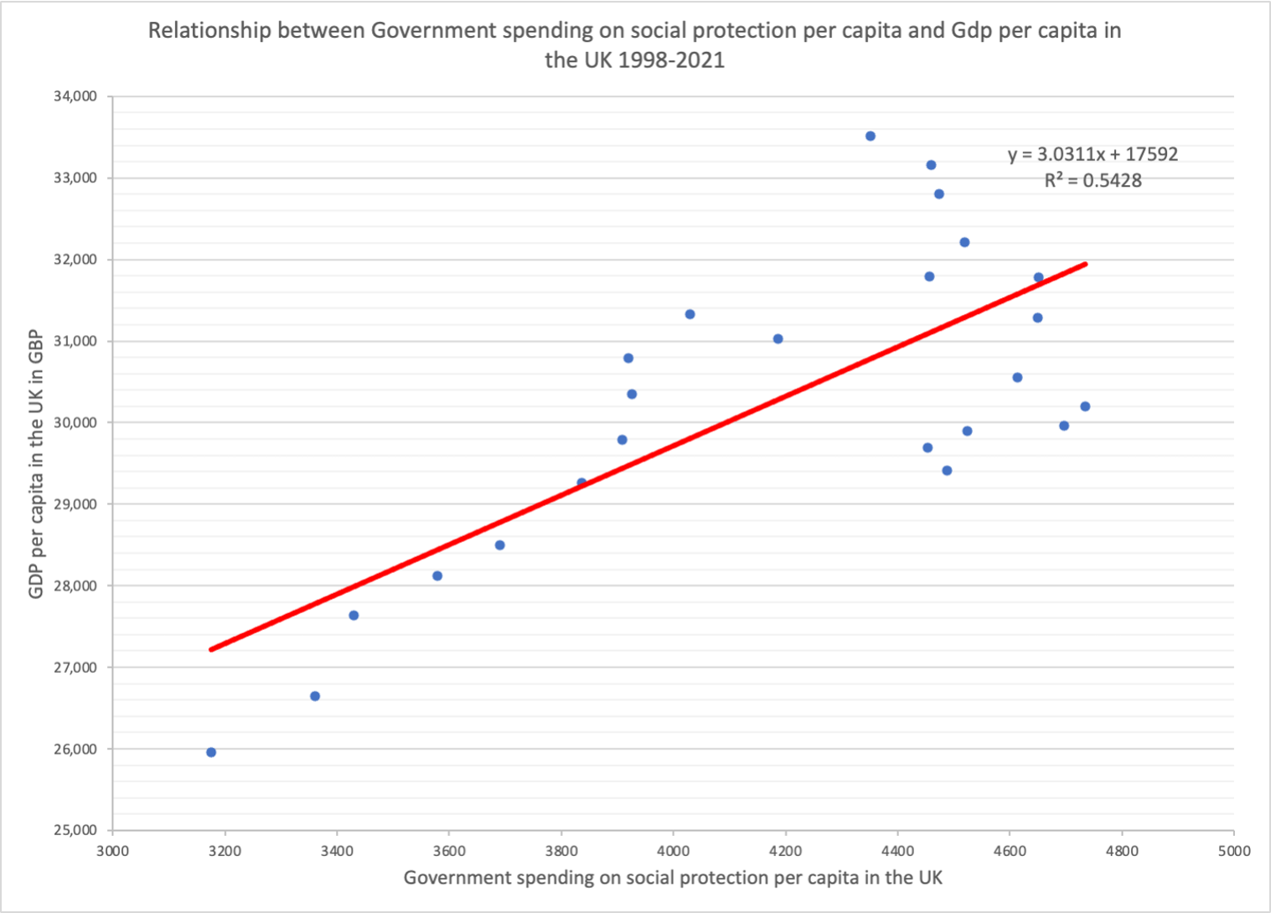

The scatter plot above graphically exhibits the relationship between social protection spending per capita and GDP per capita in the UK from 1998 to 2021. Government spending on social protection per capita is on the x axis, meaning it is the predictor variable and GDP per capita is the response variable. As the correlation value (r value) is equal to 0.737, this means that there is a strong positive correlation between the two variables. This displays that as spending per capita on social protection increases, GDP per capita will also increase and the gradient being 3.03 shows by how much GDP per capita will increase from 1 unit increase of spending on social protection per capita.

## 3.3 Analysing the relationship between GDP per capita and Health expenditure per capita

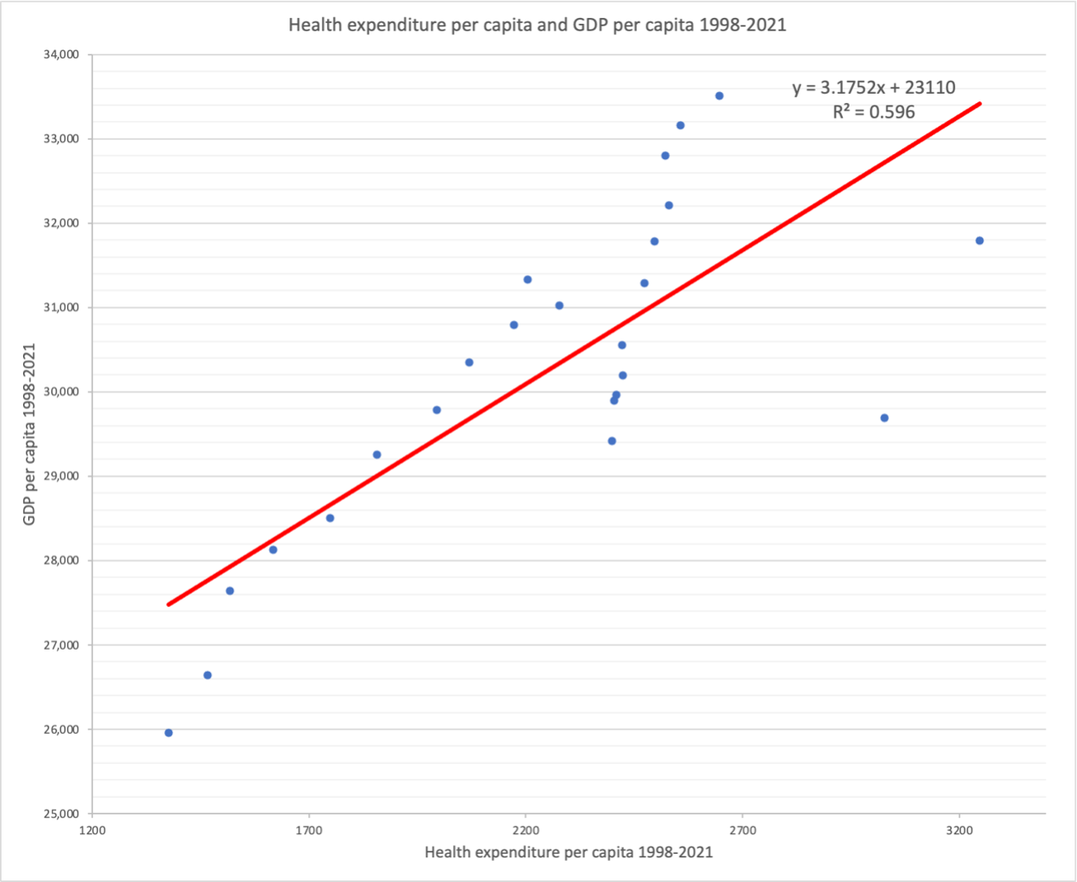

The scatter plot graph above shows the relationship between Health expenditure per capita and GDP per capita from 1998 - 2021 in the UK. Health Expenditure per capita is an explanatory variable (plotted on the x-axis) because as health expenditure per capita increases, it provides people with better quality treatments and so more productivity allowing higher GDP per capita. The correlation (r) value is 0.772 which implies a strong positive relationship between the two variables (GDP per capita and Health expenditure per capita). This means that the relationship between the GDP per capita and Health expenditure per capita moves in the same direction, meaning if one variable increases the other variable also increases and vice versa. The graph above has a linear regression line which has an equation y= 3.1752x +23110, where 3.1752 is the slope and the intercept is 23110 which is the expected mean value of GDP per capita when all Health expenditure per capita is 0. The slope of the regression line implies that if health expenditure increases by 1 unit, GDP per capita increases roughly by 3.1752. In addition, the value of r² is approximately 60% which reveals that 60% of the variability observed in the target variable is explained by the regression model.

# 4 Discussion

## 4.1 Government expenditure on Education per capita and GDP per capita

From the analysis done in section 3.1, we can clearly see that there is a direct relationship between Government expenditure on education per capita and GDP per capita. This is because education is a core component in human capital, which allows us to be more efficient at our job in the workplace due to a higher skill set being available to workers, especially for niche and specific jobs. When there is higher efficiency in the workplace, this causes a boost in overall productivity, which can help grow businesses, and therefore grow our economy (Grant 2017). This is clearly shown in the scatter plot in 3.1, where when public spending on education was at its lowest at £1070, GDP per capita was at its second lowest at £26642. However, when public spending on education per capita was at its highest at over £1700, GDP per capita was above £33000. This evidently shows the benefits of increasing our spending on education.

## 4.2 Government expenditure on Social Protection per capita and GDP per capita

In analysis 3.2, we can see from the scatter plot and our correlation value that as our predictor variable government expenditure on social protection per capita increases, GDP per capita also increases. This is likely because social protection mainly involves helping those in poverty or under benefits and are struggling within the UK. Therefore, by helping citizens in the lower income brackets, it will help reduce inequality and help those who are struggling to find jobs to enter the labor force and reduce unemployment. This in turn can help boost motivation and help improve productivity of the labor force, which is coherently shown in the scatter plot where the lowest amount of social protection spending per capita at just below £3200 also has the lowest GDP per capita which is just under £26000. The data that we have discovered stresses the importance of social protection spending where Dr Schutter’s report at the 47th session of the human rights council in Geneva, Switzerland stated that social protection “should be seen as an investment with potentially high returns, since it leads to building human capital”.

## 4.3 Government expenditure on Healthcare per capita and GDP per capita.

As seen in the previous analysis between healthcare expenditure and GDP per capita from 1998 - 2021 in the UK there is a positive relation; as healthcare expenditure increases GDP per capita also increases. This is likely because as people have better access to healthcare and medicine, their motivation and productivity increases, allowing economic growth. Healthcare expenditure usually increases due to changes in the cost of services provided and availability of services. Healthcare expenditures in the UK divided into public expenditure which is mainly spent on NHS (National Health Services) and the other is private expenditure which is spent by households and the corporate sector on healthcare. According to Our world in data, healthcare expenditure represented 9.923% of GDP and in the year 2020 and around 9.898% of GDP in 2021. In 2021 the government of UK had spent £228 billion on healthcare expenditure which was 83% of the total healthcare expenditure in the country. As the government has increased its spending on healthcare, the NHS has become a key employer in providing good terms and conditions and opportunities for high-quality, professional work and investing in training and educating staff which has contributed to the economy.

# 5 Conclusion

In the introduction of this report, we stated that our objective was to find and analyse how the government’s finances affected the growth and development of the UK economy. The variables we specifically wanted to examine were GDP per capita and the three biggest components of UK government expenditure, that being education, social protection and healthcare. From our study, we found that all three components had positive correlations and r values with GDP per capita, but expenditure on education had the strongest relationship, with its r value being 0.869.

A limitation for the analysis of government expenditure on education per capita and GDP per capita is that it excludes factors such as immigration of skilled workers from other countries to the UK. This is because workers migrate to the UK for better job opportunities, increasing GDP without obtaining an education in the country. Although this data is available, it would be hard to conclude precisely what impact this has had on an increase in overall GDP. In can be concluded that an increase in education spending per capita does increase GDP per capita to some extent but the exact impact is limited as factors such as immigration have not been accounted for.

Another limitation for analysing government expenditure on healthcare per capita is it excludes rising costs for running the NHS which includes rising medicine costs, higher salaries and bureaucracy. Although this translates to higher spending per capita, it does not necessarily mean a healthier population as more people than ever before are opting for private healthcare and health insurance (Goss 2022), which also increases GDP, showing the unreliable state of the current healthcare system where people are waiting for long hours in emergencies and months for mandatory surgeries. The graph shows that government spending on healthcare from the years 2009-2019 has changed minimally which shows the strain the healthcare system is under against a growing population. The graph only shows a big jump in the years 2020 and 2021 which is when COVID hit, and healthcare spending was the government’s top priority. This means the graph is very likely to decrease for 2022 and future years as COVID has been dealt with and is not a concern anymore meaning the increased budget in the last 2 years will be cut and diverted to other areas. This is a limitation as we do not know what budget cuts the government will impose on healthcare and how that will affect GDP. Additionally, as energy prices have increased, a higher healthcare budget will be mandatory, which on paper will increase GDP, but the quality and efficiency of healthcare will remain the same.

As for limitations with social protection expenditure and its effect on economic growth, is that unemployment benefits can cause the welfare trap where people are not willing to work and would rather stay on benefits which can affect the productivity of the labour market. (The Economic Times)

In Conclusion, the UK’s government expenditure is vital for its economy, but it is where that spending specifically goes to that plays a major part in shaping and forecasting economic growth and development. Our study has shown how spending on different sectors of society can affect growth and we can conclude that the UK government must think long and hard as to how they should allocate public finances as we try to escape the recession from the Covid pandemic and go back to developing the UK economy.

# 6 References

Clark, D. (2022) “GDP of the UK 1948-2021" Statista. Available at <https://www.statista.com/statistics/281744/gdp-of-the-united-kingdom/> (Accessed on 28/12/22)

Clark, D. (2022) “Gross domestic product per capita in the United Kingdom from 1955 to 2021 (in GBP)” Statista. Available at <https://www.statista.com/statistics/970672/gdp-per-capita-in-the-uk/>  (Accessed on 28/12/22)

Clark, D. (2022) “Public sector expenditure on social protection in the United Kingdom from 1998/98 to 2021/22” Statista. Available at <https://www.statista.com/statistics/298481/social-protection-spending-uk/> (Accessed on 28/12/22)

De Schutter, O. (2021) “Global fund for social protection: international solidarity in the service of poverty eradication” United Nations Human Rights council. Available at <https://documents-dds-ny.un.org/doc/UNDOC/GEN/G21/093/37/PDF/G2109337.pdf?OpenElement> (Accessed on 03/01/23)

Easterlin, R. (1974) “Does Economic Growth Improve the Human Lot? Some Empirical Evidence”. Available at <https://mpra.ub.uni-muenchen.de/111773/1/MPRA_paper_111773.pdf> (Accessed on 27/12/22)

Fernando, J. (2022) “Gross Domestic Product (GDP): Formula and How to Use It” Investopedia. Available at <https://www.investopedia.com/terms/g/gdp.asp> (Accessed on 23/12/22)

Goss, L. (2022) “UK’s private healthcare market booms as NHS case backlog hits record levels”. Available at <https://www.cityam.com/uks-private-healthcare-market-booms-as-nhs-case-backlog-hits-record-levels/#:~:text=More%20than%20250%2C000%20British%20people,Private%20Healthcare%20Information%20Network%20show>. (Accessed on 03/01/23)

Grant, C. (2017) “The contribution of education to economic growth”. Available at <https://assets.publishing.service.gov.uk/media/5b9b87f340f0b67896977bae/K4D_HDR_The_Contribution_of_Education_to_Economic_Growth_Final.pdf> (Accessed on 01/01/23)

Harari, D. (2022) “GDP – International Comparisons: Key Economic Indicators” House of Commons Library. Available at <https://commonslibrary.parliament.uk/research-briefings/sn02784/> (Accessed on 26/12/22)

OBR. (2022) “A brief guide to the public finances”. Available at <https://obr.uk/forecasts-in-depth/brief-guides-and-explainers/public-finances/> (Accessed on 27/12/22)

OECD. (2021) “General government spending” OECD data. Available at <https://data.oecd.org/gga/general-government-spending.htm> (Accessed on 26/12/22)

ONS. (2022) “Population estimates time series dataset”. Available at <https://www.ons.gov.uk/peoplepopulationandcommunity/populationandmigration/populationestimates/timeseries/ukpop/pop> (Accessed on 02/01/23)

ONS. (2017) “Social protection: European comparisons of expenditure, 2007 to 2014” Office for National statistics. Available at <https://www.ons.gov.uk/peoplepopulationandcommunity/wellbeing/articles/socialprotection/europeancomparisonsofexpenditure2007to2014> (Accessed on 29/12/22)

Our World in Data. () “Government health expenditure as a share of GDP, 1990 to 2021”. Available at <https://ourworldindata.org/grapher/public-health-expenditure-share-gdp-owid?time=1990..2021&country=~GBR> (Accessed on 23/12/22)

Our World in Data. (2019) “Healthcare expenditure vs. GDP, 2019”. Available at <https://ourworldindata.org/grapher/healthcare-expenditure-vs-gdp> (Accessed on 28/12/22)

Strauss, D. (2022) “UK’s growth prospects worst among top economies, warns OECD” Financial Times. Available at <https://www.ft.com/content/d6b84faf-f556-4fdd-ac27-65c2d514aa2f> (Accessed on 26/12/22)

The Economic Times, (2023) “What is ‘Unemployment Trap’”. Available at <https://economictimes.indiatimes.com/definition/unemployment-trap> (Accessed on 03/01/23)

The World Bank. (2022) “Government expenditure on education, total (% of GDP)” The World Bank data. Available at <https://data.worldbank.org/indicator/SE.XPD.TOTL.GD.ZS> (Accessed on 23/12/22)